LAB EXPERIMENT RECORD
SET 11: PRODUCT CATEGORY ANALYSIS
Department | AIDS
Course Code / Course Name | DSA0601 / Data Handling and Visualization
Experiment | Data Visualization using R
Name | B. Pallavi
Register Number | 192424243
Date | 06 October 2026
Day | Monday

Aim
To visualize product category sales data using a funnel chart, sales table, and pie chart, and to build an interactive dashboard using R and Tableau.
Dataset: Product Categories
Category | Sales (in $)
Electronics | 50000
Clothing | 35000
Appliances | 40000
PROGRAM 1: Funnel Chart of Product Category Sales
Generate a funnel chart to analyze the sales conversion process for each product category. Label the stages and title the chart.
R Code
# Dataset
category <- c("Electronics", "Clothing", "Appliances")
sales <- c(50000, 35000, 40000)

# Arrange sales from highest to lowest
sales_order <- order(sales, decreasing = TRUE)

category_sorted <- category[sales_order]
sales_sorted <- sales[sales_order]

# Funnel-style horizontal bar chart
barplot(sales_sorted,
names.arg = category_sorted,
horiz = TRUE,
main = "Product Category Sales Funnel",
xlab = "Sales ($)",
col = "skyblue",
las = 1)
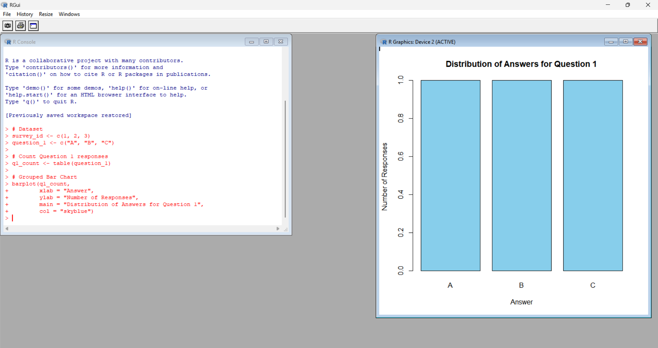
Output 1: Product Category Sales Funnel
Observation:
The funnel-style chart shows the sales values for each product category. Electronics has the highest sales of $50,000, followed by Appliances with $40,000 and Clothing with $35,000.
PROGRAM 2: Product Category Sales Table
Build a table to display the sales data for each product category. Label the table elements.
R Code
# Product Category Data
product_data <- data.frame(
Category = c("Electronics", "Clothing", "Appliances"),
Sales = c(50000, 35000, 40000)
)
# Display Table
print(product_data)
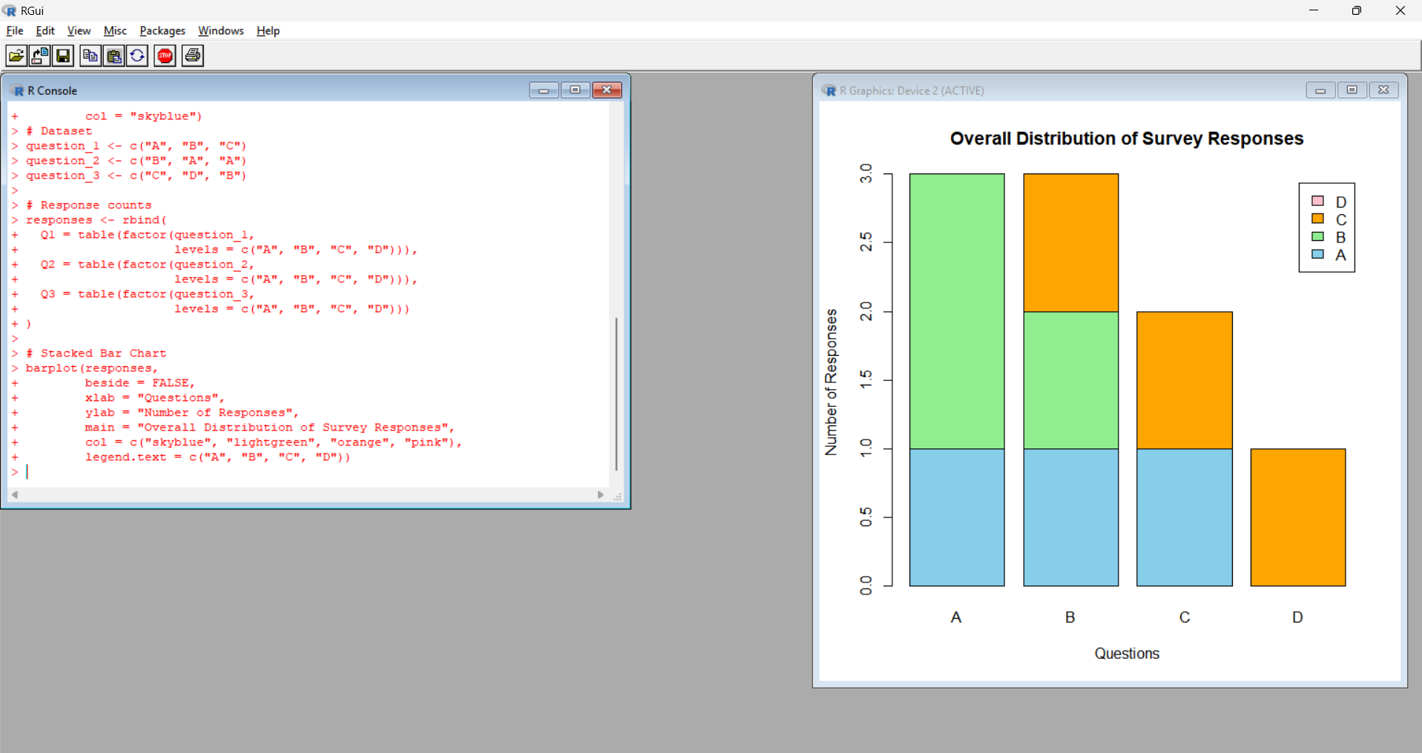
Output 2: Product Category Sales Table
Category | Sales ($)
Electronics | 50000
Clothing | 35000
Appliances | 40000
Observation:
The table displays the complete sales information for each product category.

PROGRAM 3: Product Category Dashboard
Develop a Tableau dashboard combining the pie chart, funnel chart, and table for interactive exploration of product category data.
Dataset for Tableau
Create an Excel file with the following data:
Category | Sales
Electronics | 50000
Clothing | 35000
Appliances | 40000
Save the file as:
Product_Categories.xlsx
Tableau Steps
- Open Tableau.
- Select Microsoft Excel.
- Open Product_Categories.xlsx.
- Select Sheet 1.
- Drag Category to Columns.
- Drag Sales to Rows.
- Select Bar from the Marks card.
- Arrange the categories according to sales value.
- Rename the sheet Sales Funnel.
- Create a new worksheet.
- Drag Category to Color.
- Drag Sales to Angle.
- Select Pie from the Marks card.
- Drag Sales to Label.
- Rename the sheet Sales Distribution.
- Create a new worksheet.
- Drag Category and Sales to the view.
- Select Text Table.
- Rename the sheet Product Category Sales Table.
- Click New Dashboard.
- Drag Sales Funnel into the dashboard.
- Drag Sales Distribution into the dashboard.
- Drag Product Category Sales Table into the dashboard.
- Set the title as Product Category Analysis Dashboard.
- Select Use as Filter to make the dashboard interactive.
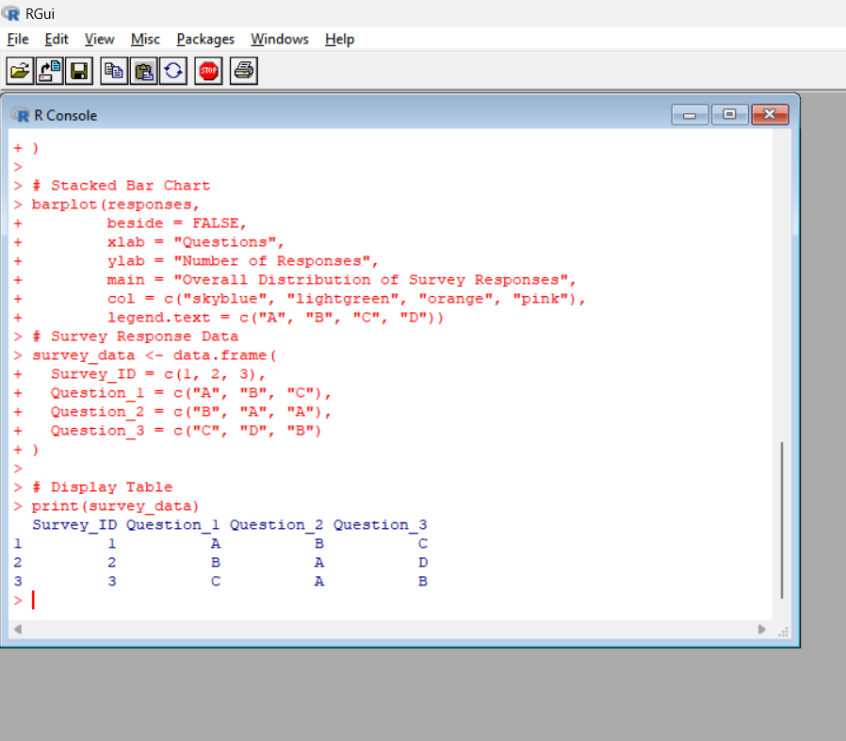
Output 3: Product Category Analysis Dashboard
Observation:
The dashboard combines the product category sales funnel, sales distribution pie chart, and detailed sales table into a single interactive view. It allows users to compare sales across different product categories.
PROGRAM 4: Pie Chart of Sales Distribution
Create a pie chart to represent the distribution of sales across product categories. Include labels.
R Code
# Dataset
category <- c("Electronics", "Clothing", "Appliances")
sales <- c(50000, 35000, 40000)
# Pie Chart
pie(sales,
labels = paste(category, "\n$", sales),
main = "Sales Distribution by Product Category",
col = c("skyblue", "lightgreen", "orange"))
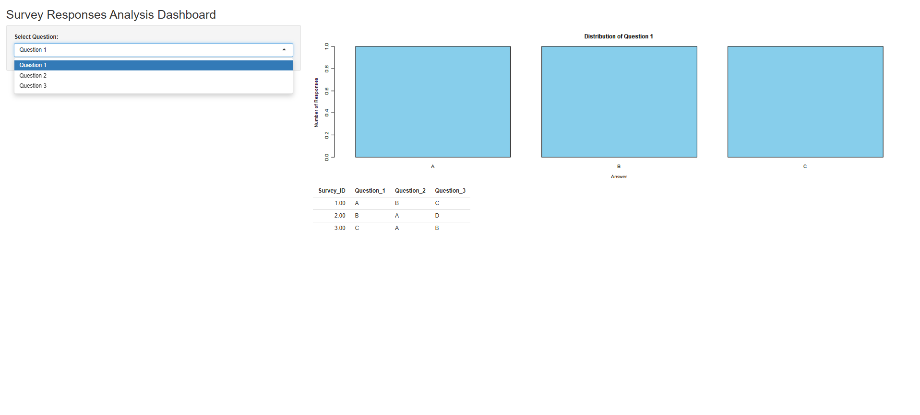
Output 4: Sales Distribution
Observation:
The pie chart represents the distribution of total sales across product categories. Electronics has the largest share of sales, while Clothing has the smallest share.
Procedure
- Create product category and sales vectors in R.
- Use barplot() to generate the funnel-style sales chart.
- Create a data frame to display product category sales information.
- Create an Excel file containing product category sales data.
- Connect the Excel file to Tableau.
- Create the sales funnel chart.
- Create the sales distribution pie chart.
- Create the product category sales table.
- Combine all three views into an interactive dashboard.
- Use filters to explore product category sales.
Result
The product category sales data was successfully visualized using a funnel chart, sales table, and pie chart. An interactive Tableau dashboard was also created to display and explore product category sales data.

